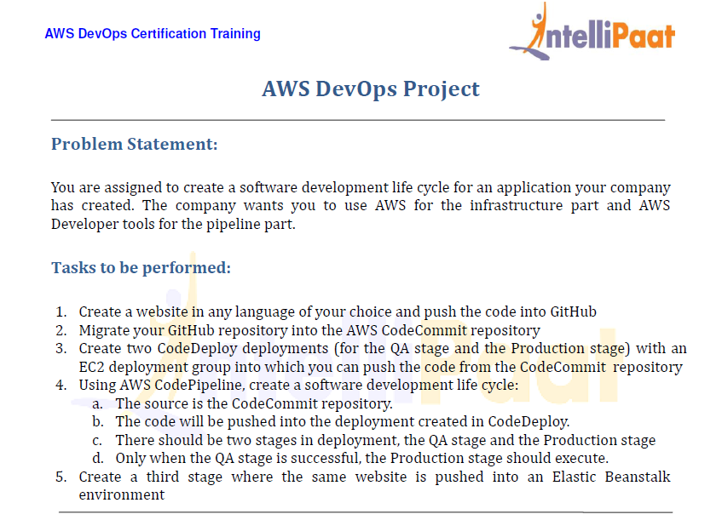

* Let us first create a instance

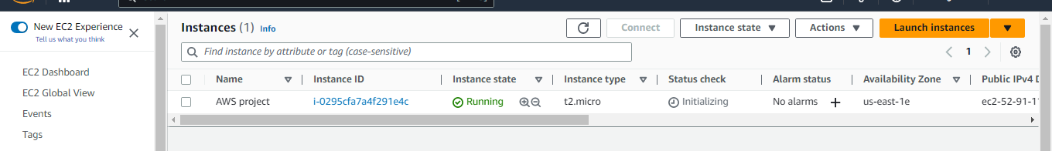

* Go to code commit and create a repository

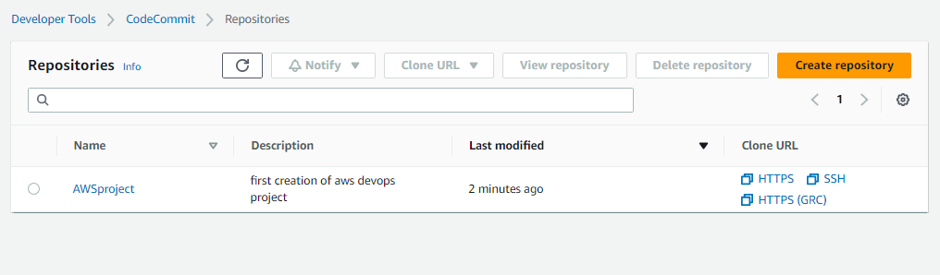

* We have a sample code in git hub, Let us clone the git hub repository

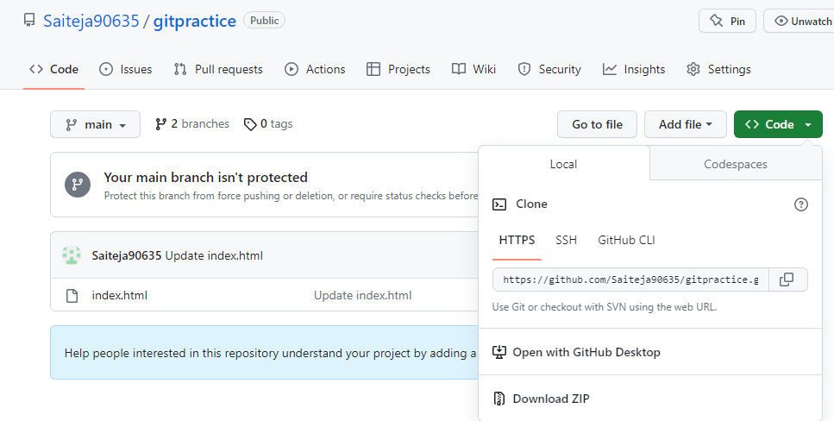

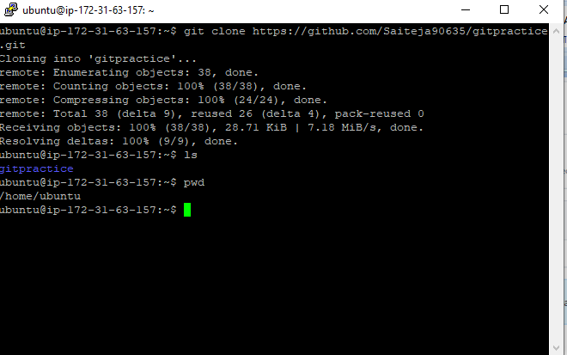

* Now let us create a IAM user for code commit in order to get the credentials.

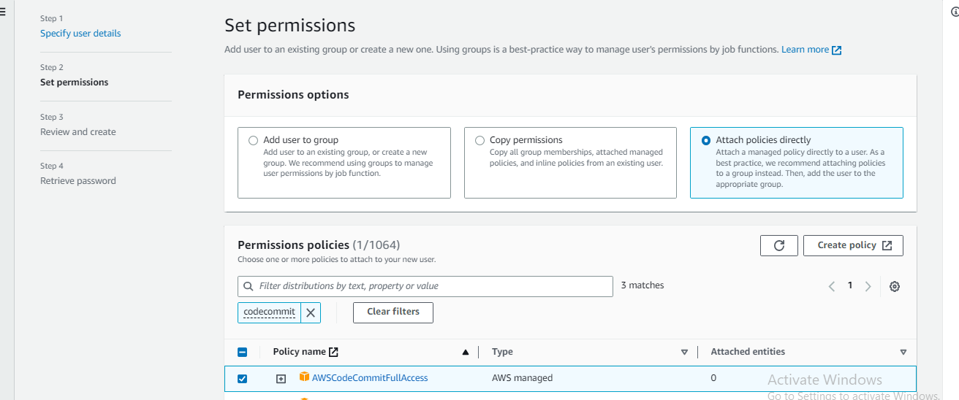

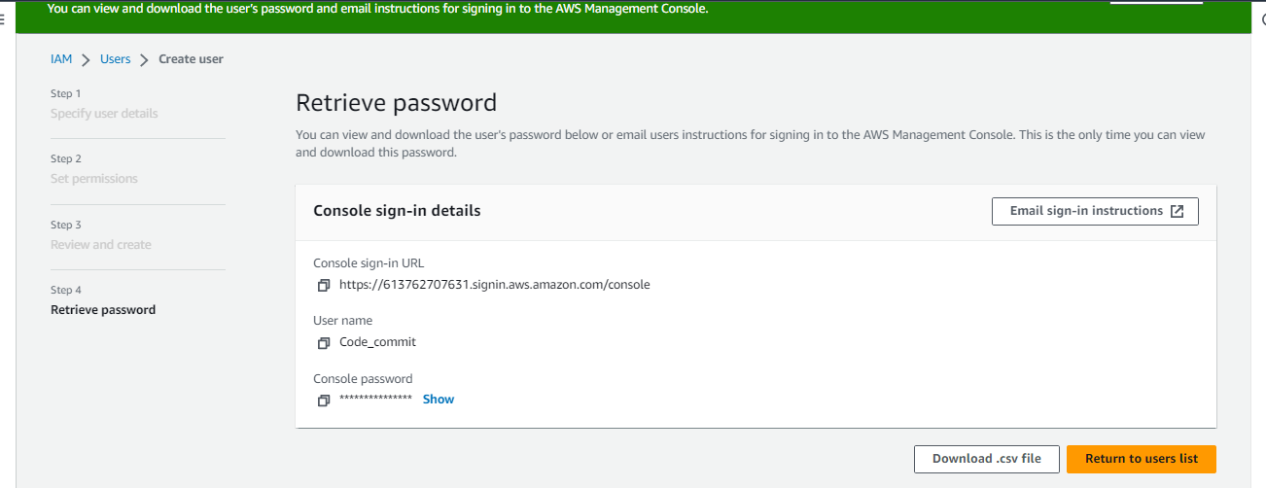

* Go to security credentials and create HTTPS credentials

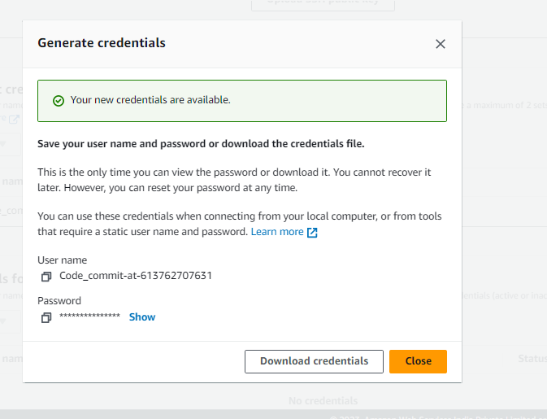

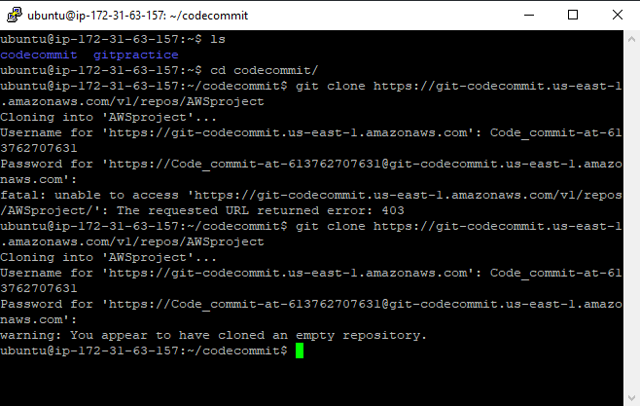

* Copy the contents in the git repository to the code commit repository

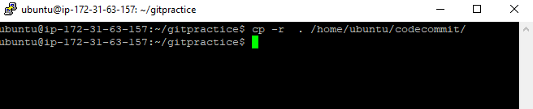

* Now stage it commit and push the code to the code commit repository

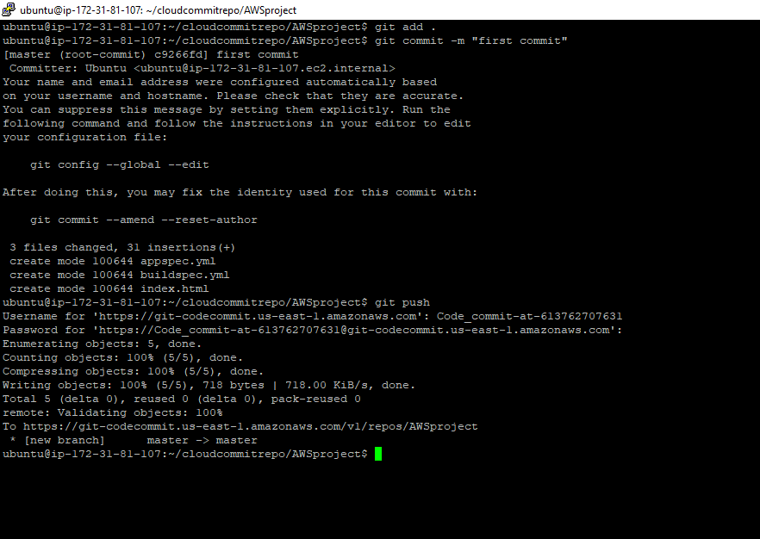

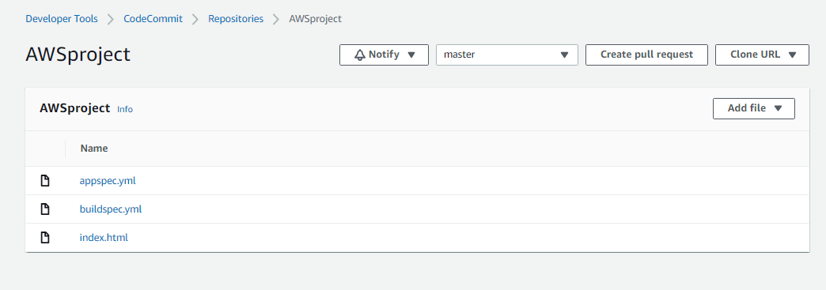

* Now create a code build

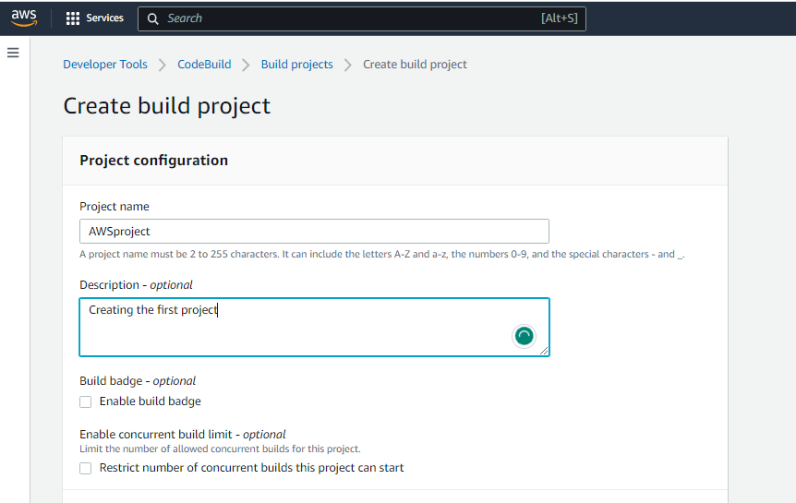

* Lets try the build

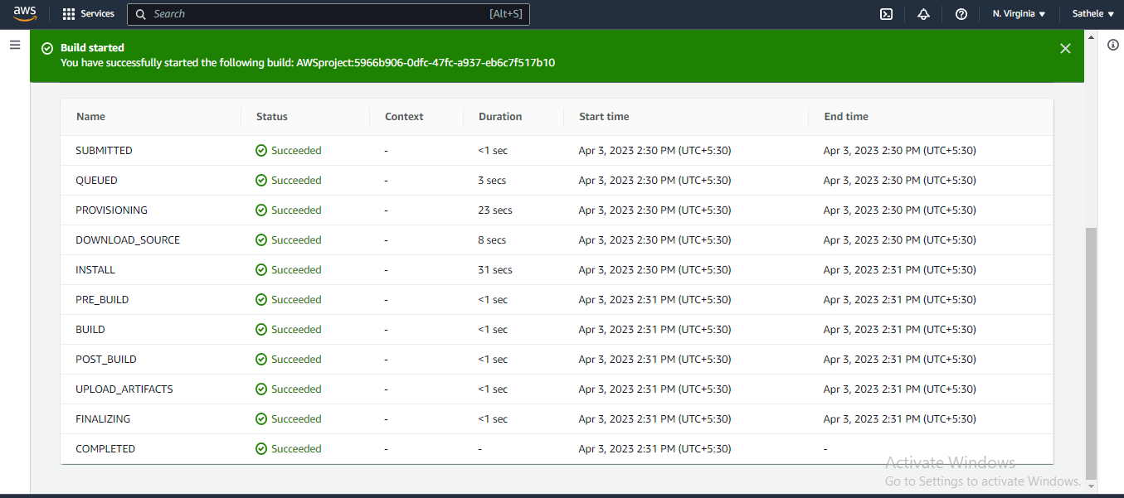

* Now let us try to create our code deploy

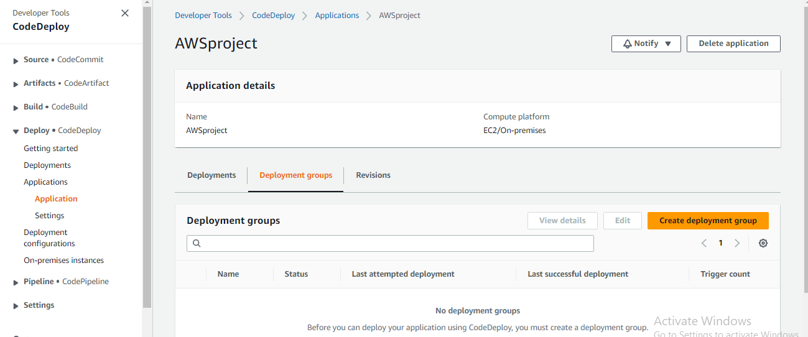

* We have created one let us configure it. We have to install the code deploy agent.

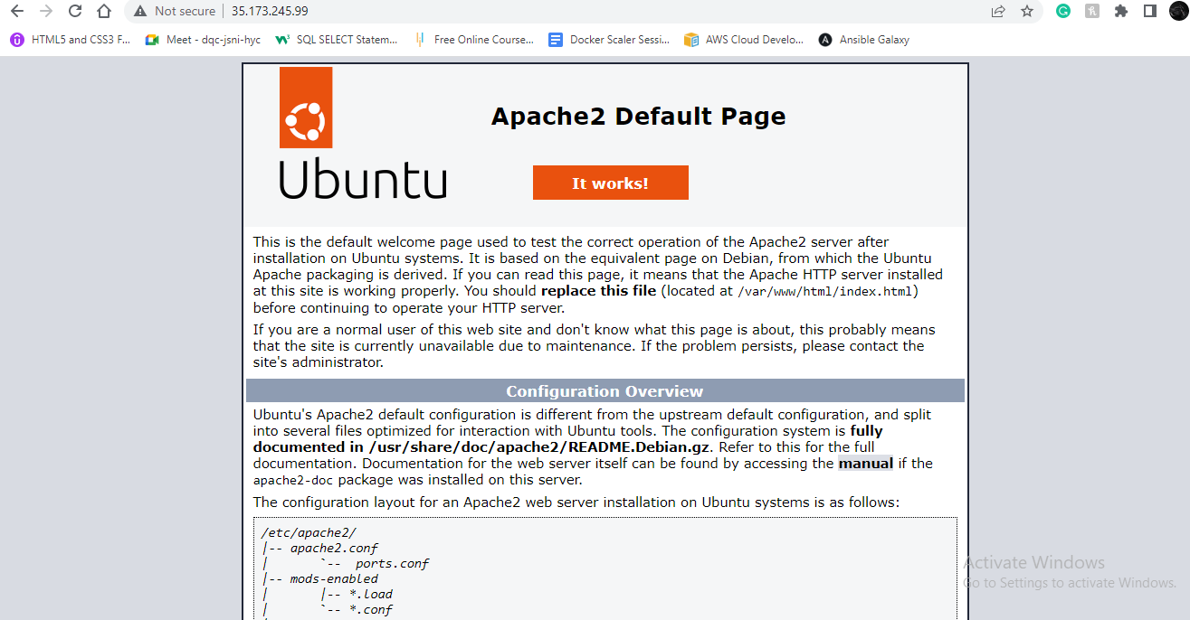

* Create a Role so that the codedeploy can access the instance

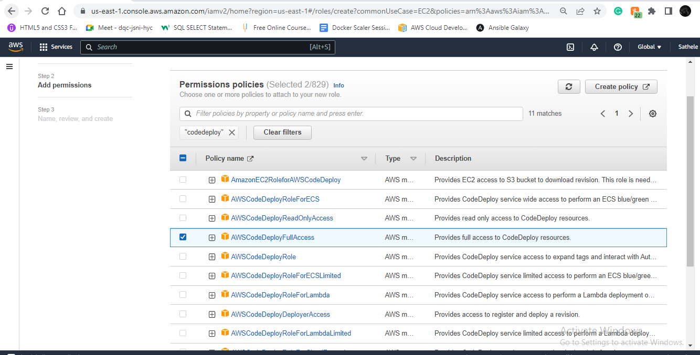

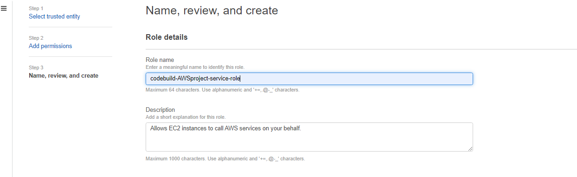

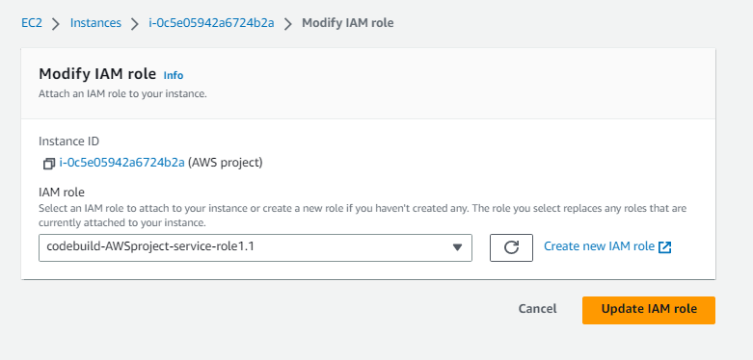

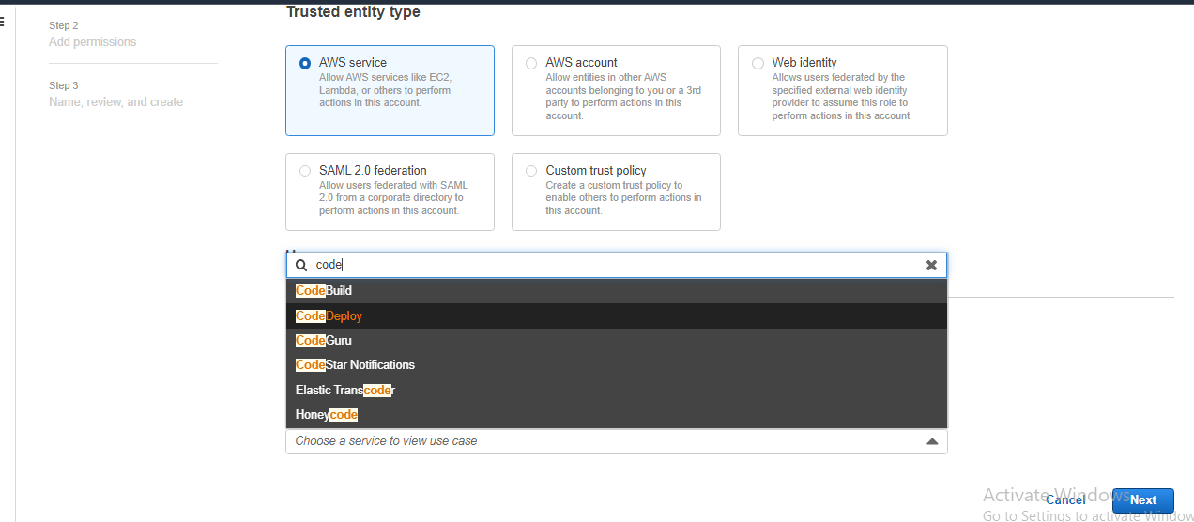

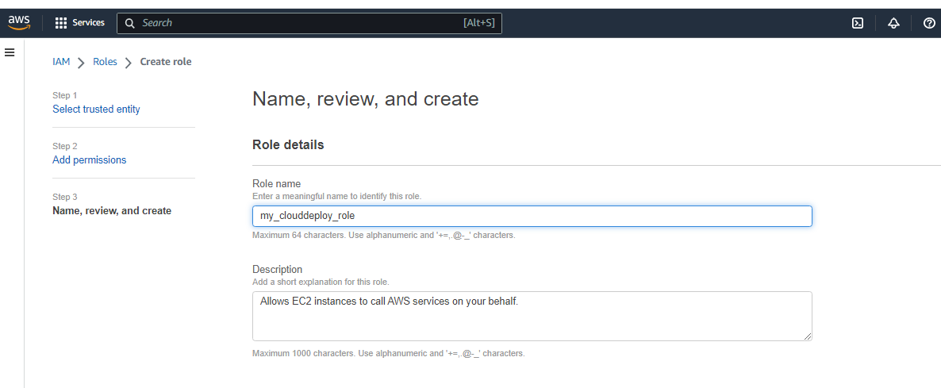

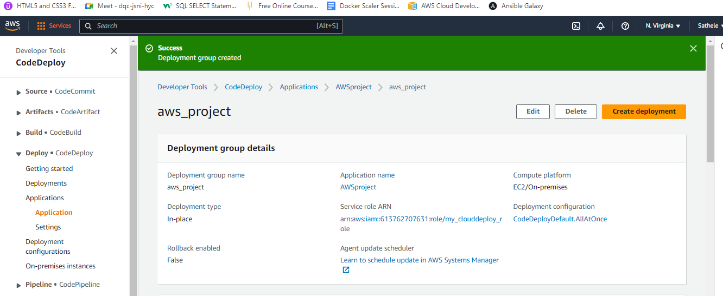

* As per the required statement we need to create two deployment stages, and only if the QA stage passes we need to proceed for Production stage, let us assume he first deployment stage to be QA.
* Now let us create the second stage

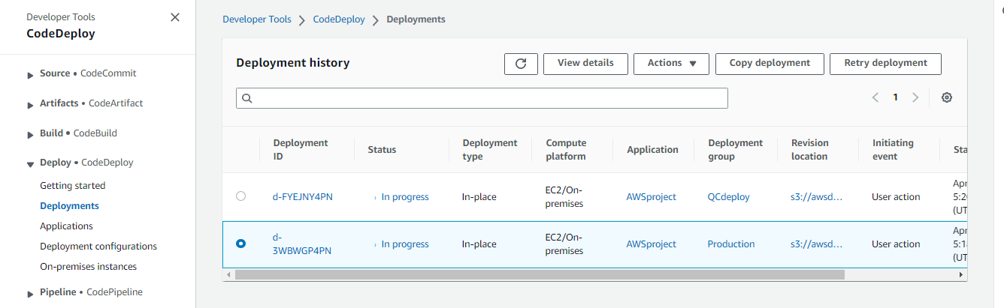

* Create a pipeline

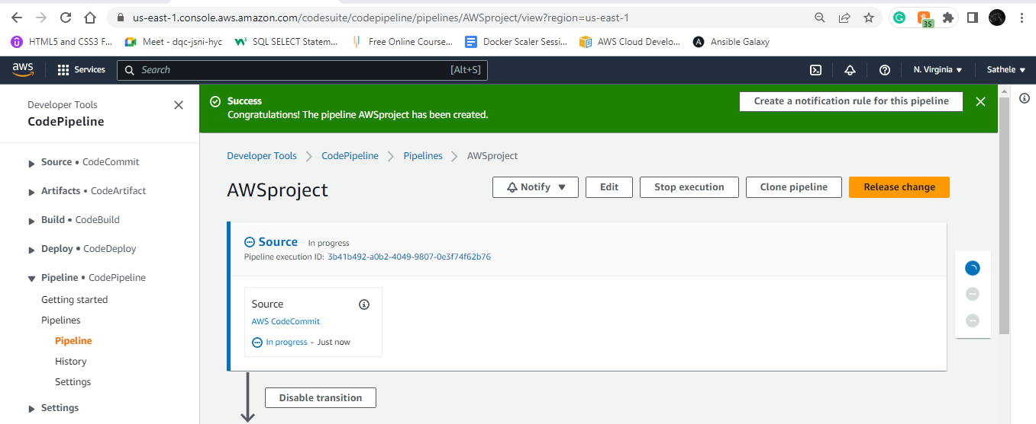

* Now we add a section for production stage in pipeline below the QC stage in the edit section

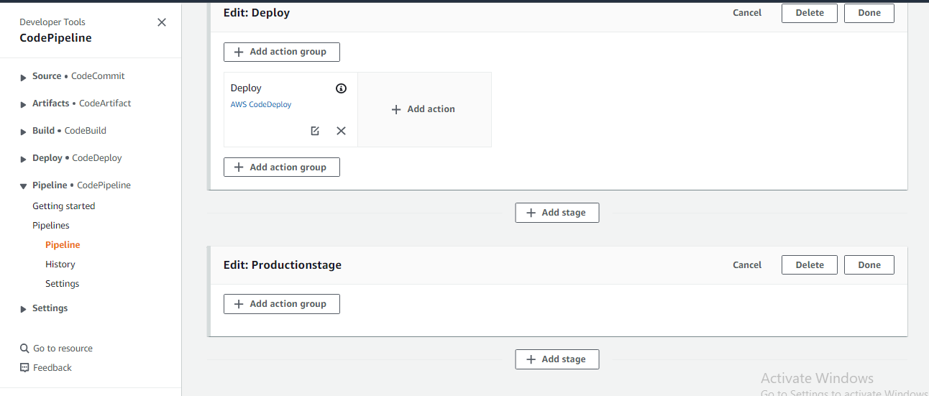

* Click on action group and add Production deployment in it

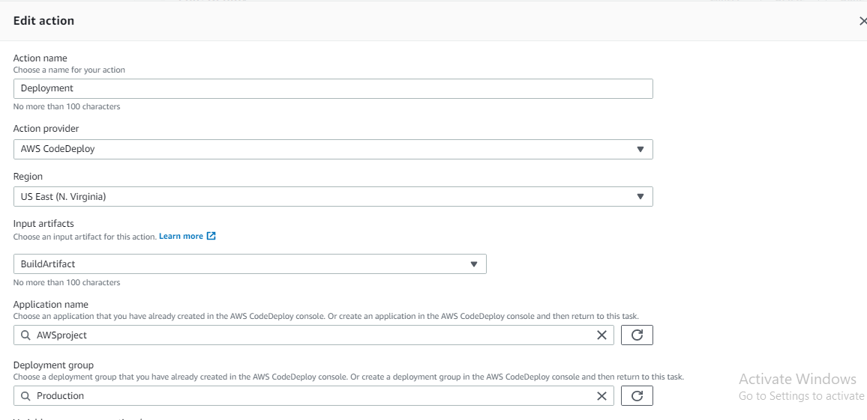

* Save the pipe line
* Create a EBS environvent
* Create a load balancer in it

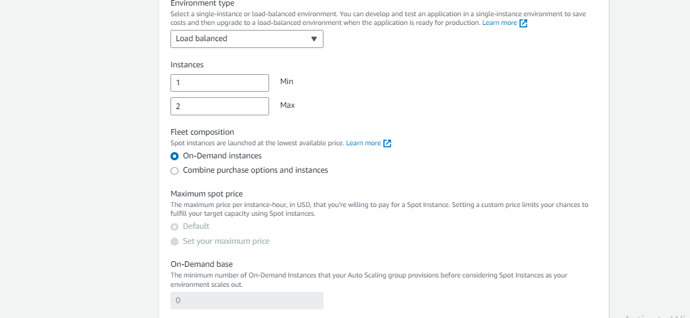

* Now we can see a auto scaling group created we can mention it in deployment group.

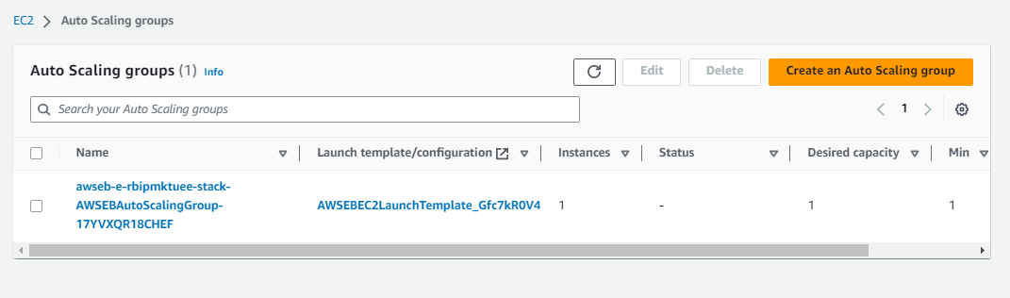

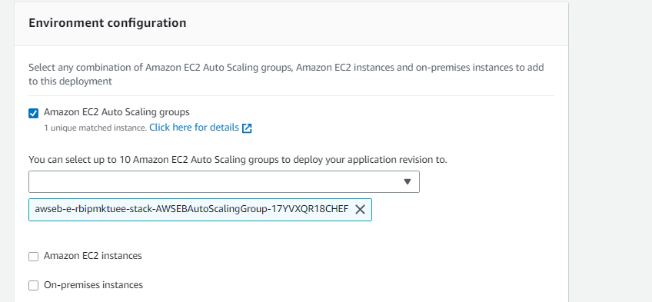

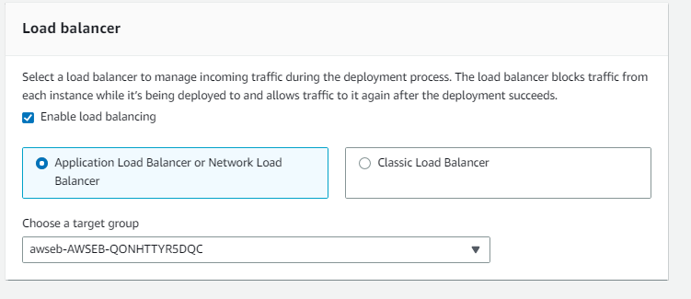

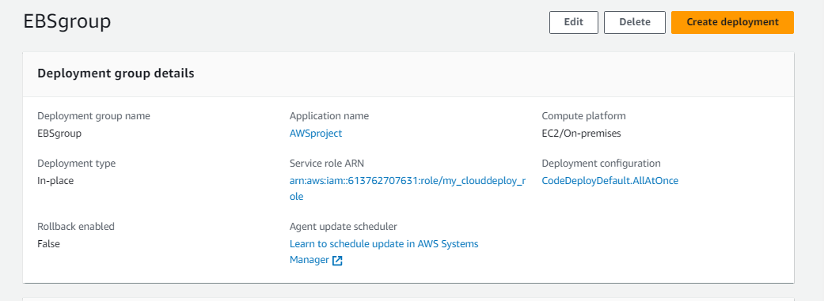

* thereby following we can push the code artifact into EBS environment